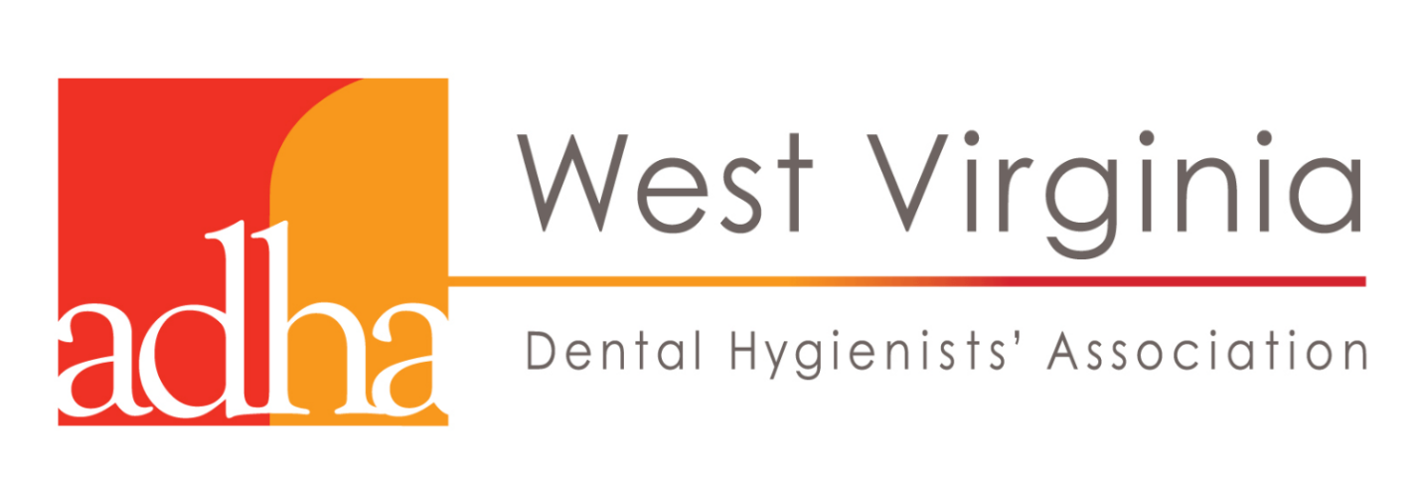
Dental Hygiene Student Scholarship Video Contest
------------------------
Official Contest Rules
- ELIGIBLE PARTICIPANTS: All students who submit entries to the video contest must be a senior enrolled in dental hygiene school within the state of West Virginia. All ideas must come from student contributors. Multiple entries by the same student are permitted. There is no entry fee.
- STANDARDS FOR VIDEO: All submissions of videos must meet the standards outlined on the following page. The judges’ decision is final. The only compensation for submitting a video is the opportunity to be awarded a prize if the entry wins.
- DEADLINE FOR SUBMISSION: All entries may be submitted to WVDHAinfo@gmail.com Your email must provide the school, grade level and name of the student. The deadline for submissions is 4:00 pm (Eastern Time, U.S.) on Saturday, March 28th, 2020.
- HOW TO SUBMIT: All entries must be submitted in a digital format, such as a MP4. For each video, the email must include the name of the student to serve as the main point of contact. Recognition will be given to the student listed on the entry form. The name of the student, their grade and the name of their school must be included in the email.
- HOW SUBMISSIONS WILL BE JUDGED: Each entry will be scored on the basis of originality, creativity, overall quality and how well it reflects the theme of the contest. Feel free to incorporate content or messages from the WVDHA website at mywvdha.org
- ORIGINAL WORK REQUIRED: Originality is one of the qualities by which entries will be judged. Plagiarism will result in disqualification. However, entries are allowed and encouraged to use content or messages from the WVDHA website at mywvdha.org Finalists may be asked to submit a list of sources for the information shared. No copyrighted materials (music, images, etc.) may be used for the contest unless the student owns the copyright or has a license to use the material for this contest. Written permission must be obtained and provided upon request for all copyrighted materials.
- IF CHOSEN AS A FINALIST: Students whose video is chosen as a “finalist” must submit a signed/completed Permission Form and a signed/completed Release Form for each person appearing in your video. Forms can be scanned and emailed to WVDHAinfo@gmail.com.
- INTELLECTUAL PROPERTY: Ownership of the underlying intellectual property that is submitted remains with the entrant, with the following exception: All entrants grant the WVDHA the right to use their names, photographs, statements, quotes, testimonials, and submitted content for advertising, publicity, and promotional purposes without notification or further compensation.
------------------------

Standards for Videos:
1. All entries must be a video. Each entry should be shared as a digital file. (See the “How to Submit” section on the previous page.)
2. Each entry must focus on "What Inspires Your Passion for the Profession of Dental Hygiene"?
3. Students must work alone.
4. The length of the video should between 1 and 2 minutes. All video entries should begin with a 10 second full-screen “title screen” that includes the following information: Name of student • School name• School city/town • Title of video
5. Content must comply with all local and national laws of the country of origin and the United States. Content must not: 1) promote illegal behavior; 2) support racial, religious, sexual or other forms of prejudice; 3) advocate sexual or violent exploitation; 4) violate rights established by law or agreement; 5) invade the privacy of any person; or 6) be otherwise inappropriate as determined by contest organizers.
6. After review, the judges will select winners for the categories below:
1st Place Winner - will receive a year’s paid membership to ADHA/WVDHA.
2nd Place Winner - will receive free admission to two WVDHA CE courses to be used within the year following graduation.
3rd Place Winner - will receive free admission to one WVDHA CE to be used within the year following graduation.
7. No video files will be returned to those who submitted them. Therefore, students should keep at least one copy of their video. WVDHA is not responsible for any submissions that are lost, damaged, or that do not upload properly.

